The Prevent duty, ‘extremism’ and ‘radicalisation’

PRESS AND COMMENTARY DIGEST, June 2020
MUST READS
Trump and Duterte Show Why UN Must Reassess Embrace of Counterterrorism
Jordan Street and Christopher Rogers
https://www.justsecurity.org/70718/trump-and-duterte-show-why-un-must-reassess-embrace-of-counterterrorism/

Labour attacks 'complacency' over delayed Prevent review
Jamie Grierson
https://www.theguardian.com/uk-news/2020/jun/09/labour-attacks-complacency-over-delayed-prevent-review

UK counter-terror programme targeted BAME women using Instagram influencers
Ian Cobain, Nadda Osman
https://www.middleeasteye.net/news/uk-prevent-stoosh-bame-women-instagram-influencers

Anger at attacks by released terrorists ‘must not distort lessons’, government warned over proposed laws
Lizzie Dearden
https://www.independent.co.uk/news/uk/home-news/terror-law-uk-attacks-government-counter-terrorism-security-bill-a9557346.html

UK counter-extremism propaganda unit extending reach around the globe
Ian Cobain, Alice Ross
https://www.middleeasteye.net/news/uk-prevent-export-tunisia-iraq-reach-around-globe

Former officer says UK police 'faked Schedule 7 airport stops' to meet targets
Richard Asheton
https://www.middleeasteye.net/news/uk-police-passengers-terror-database-targets-without-stopping

Rohingya refugees less likely to be radicalised, but violent tendencies exist, says think tank
SOO WERN JUN
https://www.malaymail.com/news/malaysia/2020/06/20/rohingya-refugees-less-likely-to-be-radicalised-but-violent-tendencies-exis/1877164

Jailed jihadis including Shamima Begum and Jack Letts should be allowed to return to Britain, ex-FBI officer says
Thomas Burrows
https://www.thesun.co.uk/news/11938723/jailed-jihadis-should-return-britain-ex-fbi-officer-says/

Reading terror attack: Suspect Khairi Saadallah was referred to Prevent counter-extremism programme
Lizzie Dearden
https://www.independent.co.uk/news/uk/crime/reading-terror-attack-khairi-saadallah-prevent-counter-extremism-a9581396.html

Defunding the Police Must Include Ending the Surveillance of Muslims
Nabihah Maqbool
https://theintercept.com/2020/06/25/defund-police-dhs-cve-program/

As Prevent Fails Again, It’s Time to Defund Counter-Terrorism and Rethink Safe Societies
Muhammad Rabbani
https://bylinetimes.com/2020/06/29/as-prevent-fails-again-its-time-to-defund-counter-terrorism-and-rethink-safe-societies/

Government
UN experts decry US rhetoric on designation of terrorist groups
https://www.ohchr.org/EN/NewsEvents/Pages/DisplayNews.aspx?NewsID=25980

#SafeguardingWeek2020: Counter terrorism police urge awareness of online risks to young people
North Yorkshire Police
https://northyorkshire.police.uk/news/safeguardingweek2020-counter-terrorism-police-urge-awareness-of-online-risks-to-young-people/

Reports and Papers
Seeing and unseeing Prevent’s racialized borders
Nadya Ali
https://journals.sagepub.com/doi/full/10.1177/0967010620903238

A fourth pillar for the United Nations? The rise of counter-terrorism
SAFERWORLD
https://www.saferworld.org.uk/resources/publications/1256-a-fourth-pillar-for-the-united-nations-the-rise-of-counter-terrorism

‘(S)extremism’: Imagining Violent Women in the Twenty-First Century with Navine G. Khan-Dossos and Julia Kristeva
Lisa Downing
https://www.euppublishing.com/doi/full/10.3366/para.2020.0333

False Positives: the Prevent counter-extremism policy in healthcare
Medact
https://www.medact.org/2020/resources/reports/false-positives-the-prevent-counter-extremism-policy-in-healthcare/

Book
Forced Out
Kevin Maxwell
https://www.abebooks.co.uk/servlet/BookDetailsPL?bi=30657265513&searchurl=kn%3Dforced%2Bout%2Bkevin%2Bmaxwell%26sortby%3D17&cm_sp=snippet-_-srp1-_-title1

Other
Anti-Muslim Hatred Working Group
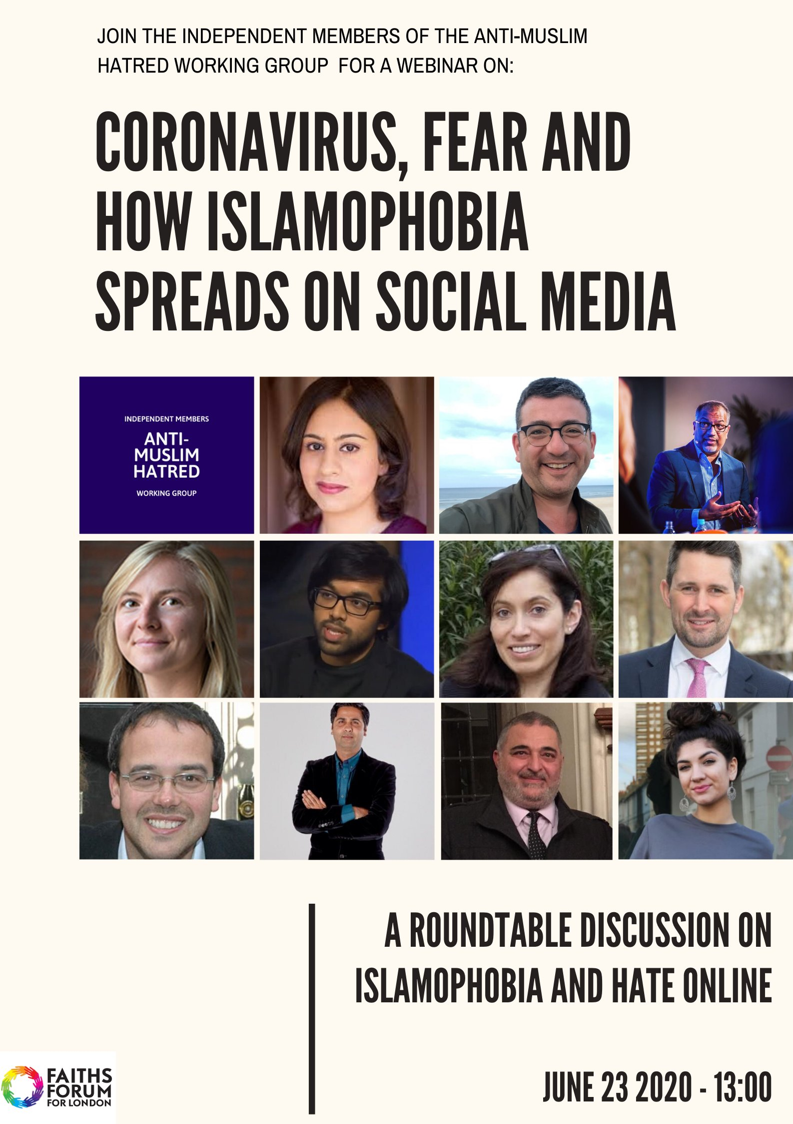
https://twitter.com/AMHWGuk?s=20

04.06.20
Race relations charity criticised over attacks on Prevent and MP
Helen Pidd
https://www.theguardian.com/world/2020/jun/04/race-relations-charity-criticised-over-attacks-on-prevent-and-mp

09.06.20
Labour attacks 'complacency' over delayed Prevent review
Jamie Grierson
https://www.theguardian.com/uk-news/2020/jun/09/labour-attacks-complacency-over-delayed-prevent-review

UK counter-terror programme targeted BAME women using Instagram influencers
Ian Cobain, Nadda Osman
https://www.middleeasteye.net/news/uk-prevent-stoosh-bame-women-instagram-influencers

10.06.20
Anger at attacks by released terrorists ‘must not distort lessons’, government warned over proposed laws
Lizzie Dearden
https://www.independent.co.uk/news/uk/home-news/terror-law-uk-attacks-government-counter-terrorism-security-bill-a9557346.html

Coronavirus: Police warn of lockdown radicalisation threat
Gordon Corera
https://www.bbc.co.uk/news/uk-52997441

Terrorism threat same as before lockdown – police chief
PA
https://www.largsandmillportnews.com/news/national-news/18507969.terrorism-threat-lockdown---police-chief/

UK extremism commission looks to ban hate behaviour
Nicky Harley
https://www.thenational.ae/world/uk-extremism-commission-looks-to-ban-hate-behaviour-1.1031730

11.06.20
UK counter-extremism propaganda unit extending reach around the globe
Ian Cobain, Alice Ross
https://www.middleeasteye.net/news/uk-prevent-export-tunisia-iraq-reach-around-globe

GoBubble: the teacher-approved social network for kids
Amelia Heathman
https://www.standard.co.uk/tech/gobubble-social-network-for-kids-how-it-works-a4464691.html

Trump and Duterte Show Why UN Must Reassess Embrace of Counterterrorism
Jordan Street and Christopher Rogers
https://www.justsecurity.org/70718/trump-and-duterte-show-why-un-must-reassess-embrace-of-counterterrorism/

13.06.20
How the UK’s far right is trying to capitalise on the statues row
Lizzie Dearden
https://www.independent.co.uk/news/uk/home-news/uk-far-right-protests-statues-black-lives-matter-tommy-robinson-a9564051.html

16.06.20
Former officer says UK police 'faked Schedule 7 airport stops' to meet targets
Richard Asheton
https://www.middleeasteye.net/news/uk-police-passengers-terror-database-targets-without-stopping

17.06.20
Number of far-right terrorist prisoners in Britain hits record high
Dan Sabbagh
https://www.theguardian.com/world/2020/jun/17/number-of-far-right-terrorist-prisoners-in-britain-hits-record-high

18.06.20
Terror groups 'exploiting coronavirus pandemic to radicalise new recruits', QC warns
Tristan Kirk
https://www.standard.co.uk/news/crime/coronavirus-terrorism-lord-carlile-warning-a4473436.html

British government has spent 200 million pounds on prevent in the last five years
Muslim View
http://muslimview.co.uk/news/british-government-has-spent-200-million-pounds-on-prevent-in-the-last-five-years/

20.06.20
Rohingya refugees less likely to be radicalised, but violent tendencies exist, says think tank
SOO WERN JUN
https://www.malaymail.com/news/malaysia/2020/06/20/rohingya-refugees-less-likely-to-be-radicalised-but-violent-tendencies-exis/1877164

School closures putting vulnerable pupils at risk of radicalisation by extremists online, warn police
Hayley Dixon
https://www.telegraph.co.uk/news/2020/06/20/school-closures-putting-vulnerable-pupils-atrisk-radicalisationby/

21.06.20
Reading terror attack: Libyan suspect may have considered travelling abroad to join Islamist group, security sources say
Kim Sengupta & Lizzie Dearden
https://www.independent.co.uk/news/uk/home-news/khairi-saadallah-uk-police-terrorism-isis-prevent-a9578031.html

22.06.20
'Obsession' with catching far-right extremists to 'appease the hard left' in Britain is diverting police, MI5 agents and public money away from stopping dangerous jihadis, intelligence expert warns
Martin Robinson and Dan Sales
https://www.dailymail.co.uk/news/article-8447049/Obsession-catching-far-right-extremists-diverting-police-stopping-dangerous-jihadis.html

Why we should deny the Reading attacker the prominence he seeks
Stephen Bush
https://www.newstatesman.com/politics/uk/2020/06/why-we-should-deny-reading-attacker-prominence-he-seeks

23.06.20
Threat from extremists carrying out UK terror attacks ‘growing’, says Patel
Paris Gourtsoyannis
https://www.scotsman.com/news/crime/threat-extremists-carrying-out-uk-terror-attacks-growing-says-patel-2892071

It takes more than ideas to make an extremist
Melanie Phillips
https://www.thetimes.co.uk/edition/comment/it-takes-more-than-ideas-to-make-an-extremist-2hvjp90kv

Muslim convert who planned to bomb St Paul's Cathedral was vulnerable to radicalisation, court told
Simon Rushton
https://www.thenational.ae/world/europe/muslim-convert-who-planned-to-bomb-st-paul-s-cathedral-was-vulnerable-to-radicalisation-court-told-1.1037635

Violent attacks by radicalised mentally ill people can be 'impossible to distinguish' from acts of terrorism, Europol warns in new report
Nick Enoch
https://www.dailymail.co.uk/news/article-8452023/Attacks-radicalised-mentally-ill-people-impossible-distinguish-acts-terrorism.html

24.06.20
Jailed jihadis including Shamima Begum and Jack Letts should be allowed to return to Britain, ex-FBI officer says
Thomas Burrows
https://www.thesun.co.uk/news/11938723/jailed-jihadis-should-return-britain-ex-fbi-officer-says/

Reading terror attack: Suspect Khairi Saadallah was referred to Prevent counter-extremism programme
Lizzie Dearden
https://www.independent.co.uk/news/uk/crime/reading-terror-attack-khairi-saadallah-prevent-counter-extremism-a9581396.html

25.06.20
Cannock schools campaign on extremism a success
Harriet Evans
https://www.expressandstar.com/news/education/2020/06/25/cannock-schools-campaign-on-extremism-a-success/

CAGE accuses The Times of fabricating story over ‘links’ to alleged Reading stabber
5 Pillars
https://5pillarsuk.com/2020/06/25/cage-accuses-the-times-of-fabricating-story-over-links-to-alleged-reading-stabber/

Defunding the Police Must Include Ending the Surveillance of Muslims
Nabihah Maqbool
https://theintercept.com/2020/06/25/defund-police-dhs-cve-program/

27.06.20
Reading stabbings: Labour calls for review of 'lone actor' terrorism after third attack in seven months
Lizzie Dearden
https://www.independent.co.uk/news/uk/home-news/reading-stabbing-terrorism-labour-review-khairi-saadallah-london-bridge-a9587006.html

28.06.20
Coronavirus: 'Children may have been radicalised in lockdown'
Caleb Spencer
https://www.bbc.co.uk/news/uk-wales-53082476

Priti Patel defies her critics to expand Prevent anti-terror drive amid fears large areas of Britain are living dangerously unprotected from extremists
Abul Taher
https://www.dailymail.co.uk/news/article-8466797/Priti-Patel-defies-critics-expand-Prevent-anti-terror-drive.html

Until UK tackles extremism, intelligence community is set up to fail
Ronald Sandee
https://www.express.co.uk/comment/expresscomment/1302061/Counter-terrorism-extremism-ronald-sandee-intelligence

29.06.20
Boost NHS mental health youth services to tackle radicalisation, say psychiatrists
Robert Booth
https://www.theguardian.com/society/2020/jun/29/boost-nhs-mental-health-youth-services-to-tackle-radicalisation-say-psychiatrists

As Prevent Fails Again, It’s Time to Defund Counter-Terrorism and Rethink Safe Societies
Muhammad Rabbani
https://bylinetimes.com/2020/06/29/as-prevent-fails-again-its-time-to-defund-counter-terrorism-and-rethink-safe-societies/

